**Baseline Assessment of Faga’alu Watershed: A Ridge to Reef Assessment in Support of Sediment Reduction Activities**

**Purpose and Objective**

The primary purpose of this document is to provide local and federal partners with baseline information and survey methodologies to enable partners the ability to monitor effectiveness of management actions. This document summarizes work completed between 2012 and 2014 which was coordinated and funded by the National Oceanic and Atmospheric Administration (NOAA) Coral Reef Conservation Program (CRCP) to gather baseline data and information in Faga’alu, American Samoa before a management intervention was implemented to reduce land-based sources of pollution. The work described in the following sections was funded through investments made by the NOAA CRCP either directly through an internal NOAA project titled, “Comprehensive baseline assessment and pilot test of outcome performance measures in Faga’alu Bay, American Samoa”, through a Cooperative Agreement with American Samoa to the Coral Reef Advisory Group, or through a domestic grant awarded to San Diego State University (SDSU) titled, “Monitoring and analysis of sediment accumulation and composition on coral reefs in Faga'alu Bay, American Samoa” which extended previous efforts on this effort supported by the Department of Interior – Insular Affairs Office.

To carry out these baseline assessments, experts from across NOAA and SDSU were asked to apply their knowledge and technical skills to develop baseline information to share with the local management authorities in American Samoa so that the effectiveness of the intervention can be determined. These 2012-2014 activities describe the pre-intervention baseline data collection, analysis, and interpretation needed to evaluate the effectiveness of the intervention over the long term. In order to understand the effectiveness of the intervention, additional long-term monitoring will be required and the data from that monitoring will be compared to these baselines. The overall efforts required to evaluate the effectiveness of the intervention is large, and will require a division of labor between local and federal efforts. With the baseline data collection completed through the support of the NOAA CRCP, the remainder of ongoing long-term monitoring using the methods already employed will be needed in order to determine effectiveness of the actions taken at the quarry and should transition into the hands of the local management authorities.

**Introduction**

In August 2012, Faga’alu, American Samoa was chosen by the US Coral Reef Task Force (USCRTF) as a priority watershed site for the Watershed Partnership Initiative (WPI). In 2009, the WPI was launched in Guanica, Puerto Rico and is an active effort of the USCRTF to reduce land-based sources of pollution (LBSP) by facilitating and enhancing coordination, partnerships, and contributions of agency resources and expertise to implement geographically specific integrated activities to reduce pollutant loads to coral reef ecosystems. The WPI also promotes consistent and strengthened application and enforcement of laws and authorities intended to address LBSP within the U.S. coral reef jurisdictions. Currently, the WPI is active in three watersheds: Guanica, Puerto Rico, West Maui, Hawaii, and Faga’alu, American Samoa.

In a separate process conducted in 2010 by NOAA’s CRCP to identify management priorities in the US coral reef jurisdictions, the American Samoan resource managers, invited management advisors, and science advisors identified Faga’alu as one of two priority geographies in American Samoa based on biological value, degree of risk and threat, and management effectiveness (CRCP, 2010). Additionally, as a result of the 2010 management priority setting process three strategic coral reef management goals were identified including the following which is aimed at reducing LBSP: “*Goal 2: Improve coastal watershed quality and enhance coral reef ecosystem function and health by reducing land-based sources of pollution*”.

In August of 2012, the Village of Faga’alu also completed its Watershed Management and Conservation Plan, which was prepared in collaboration with American Samoa’s Land-based Sources of Pollution Local Action Strategy Group. This plan identified sedimentation as a key threat to the Faga’alu watershed. By the end of 2012, with the above processes complete and the village plan as a guide, the CRCP began to provide resources and coordinate activities in Faga’alu to monitor baselines and to address the threat of LBSP, specifically the sedimentation issues and resulting turbidity found in Faga’alu Stream and Faga’alu Bay which do not pass the American Samoa Water Quality Standards (ASWQS). Excessive turbidity is in part responsible for placing Faga’alu on the 303(d) list of impaired waters according to the American Samoa Environmental Protection Agency (ASEPA). Other parameters that do not meet the ASWQS include total Nitrogen, total Phosphorus, dissolved Oxygen, and *Enterrococcus* bacteria levels.

**Context**

*Geographic*

Faga’alu is a relatively small, steep coastal watershed located southwest of Pago Pago Harbor on Tutuila Island in American Samoa. This watershed is 0.96 square miles and sits above Faga’alu Bay which is bounded to the north by Tulutulu Point and to the south by Niuloa Point. Within the watershed there is Faga’alu Village (population 910, US Census 2010), the only hospital in American Samoa, a popular public beach park, Matafao Elementary School, and several businesses – including Samoa Maritime Company, an open pit quarry located above the village. The excess sedimentation affecting Faga’alu village is believed to come from the quarry, making the Samoa Maritime quarry a target for mitigation actions to reduce the amount of sediments leaving Faga’alu watershed. The sediments flow from the quarry into Faga’alu stream then out into Faga’alu Bay where a shallow lagoon and a fringing reef exists.

*Hydrodynamic*

Faga’alu reef is divided into two shallow reef flats by a deep channel through the reef (‘ava in Samoan language) where water pumped in over the reef crest by waves returns to sea. Based on hydrodynamic measurements in Faga’alu Bay, water circulation over the reef flat is driven by waves and winds and generally moves clockwise from south to north, and then out to Pago Pago Harbor (Figure xx). Current speeds are typically highest and residence times lowest over the southern reef; speeds are lowest and residence times high in the ‘ava channel and on the northern reef. When storms cause sediment-rich discharge from Faga’alu stream into the northwest corner of the bay, this pattern of water circulation over the reef flat carries the sediment to the north, damaging the northern and ‘ava areas but leaving the far southern reef relatively unaffected.

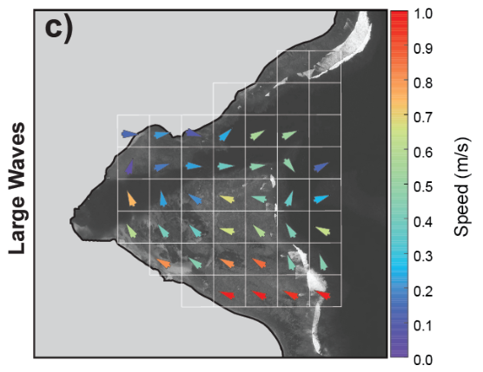

Figure xx. Gridded mean current speeds and directions for 100 m2 grid cells based on drifter data. Velocities are lower but directions are similar during small waves and wind events. Messina, unpublished data.

Owing to the relatively small volume of the bay, calculated flushing times vary from just a few hours to a small number of days. Based on data from an ADCP (Acoustic Doppler Current Profiler) deployed in the channel, flushing times are shortest during high tide and high wave events, with a total flushing time of < 1 hour during the highest observed wave and tide event, whereas during periods of low waves, flushing times can prolong for nearly 33 hrs. (Figures XYa, b)

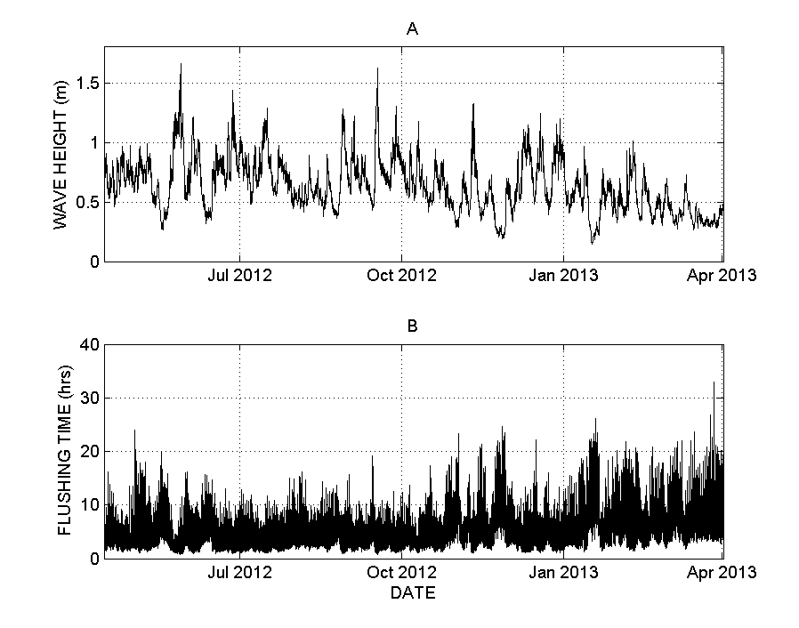

Figure XY (A & B). Faga’alu Bay wave height and estimated flushing based on ADCP data

**Mitigation Actions/Intervention**

Since the designation of Faga’alu as a priority site for the WPI, multiple entities, including the National Fish and Wildlife Foundation (NFWF), the Coral Reef Advisory Group (CRAG) in American Samoa, ASEPA, and NOAA CRCP have engaged in discussions with Samoa Maritime to implement a corrective action plan at the quarry. This plan included multiple steps to address both dry and wet season conditions.

1. To mitigate constant groundwater flow from coming into contact with loose/erodible sediments on the haul roads and processing area of the quarry, and to stem dry weather discharge of turbid water to the stream, two groundwater drainage diversions were added between August-November 2012 at two locations immediately below exposed rock face to intercept clean groundwater flow and direct it around the active site into the stream.
2. In 2013 the roadways within the quarry grounds were covered with larger gravel to minimize mobilization of surface sediments and reduce tracking from equipment tires during wet conditions.
3. In September-December 2014 two retention ponds were installed to capture sediment-rich runoff from the whole site, before it could be discharged into the stream during heavy rainfall conditions. The retention ponds allow the sediment-free water to percolate through the ground and into the stream, leaving the sediment behind in the retention pond.

The engineering designs for the interventions at Samoa Maritime quarry were developed by Horsley Witten Group, and were built into the corrective action plan for the quarry to implement using their own equipment and time, as well as a combination of funding from NFWF, NOAA, CRAG to cover supplies and hauling of the excavated material from the retention ponds. Any costs exceeding the amount of funds provided were assumed by the quarry. Coordination for the on-site work was handled by ASEPA, CRAG, and NOAA CRCP staff based in American Samoa in cooperation with Samoa Maritime staff. Several site visits were conducted during the implementation of the corrective action plan to ensure that the work was in alignment with the plans prepared by Horsley Whitten with final sign off responsibility resting with technical staff at ASEPA.

**Rationale for Collection of Baseline Data**

*Sediments*

Building upon a two-year grant from Department of Interior – Insular Affairs to SDSU to measure sediment discharge from Faga’alu watershed, NOAA funded another 2 years of work in 2013 to SDSU for a project titled, “Monitoring and analysis of sediment accumulation and composition on coral reefs in Faga'alu Bay, American Samoa”, to continue the sediment load monitoring in Faga’alu stream and to expand the work to look at sediment composition and deposition in Faga’alu Bay. The data collected through these projects provide a comprehensive baseline by measuring sediment loading in the stream above the quarry, immediately below the quarry, and farther down the stream close to where it enters the bay. Sediment loads can be extremely variable so having data collection starting in 2012 provided enough time for data gathering efforts in wet and dry seasons to cover the variability of sediment loading due to storm size prior to mitigation efforts taken at the quarry. The analysis presented here looks at storms of similar sizes from before and after the intervention to be able to determine the effectiveness of the intervention.

*Corals*

In order to obtain pre-intervention baselines for the coral community structure and coral demographics in Faga’alu Bay, NOAA’s capabilities in coral reef ecosystem monitoring were put into action to gather data for coral reef community structure of Faga’alu Bay. Surveys were conducted during the NOAA reef assessment and monitoring cruise in American Samoa in 2012, and additional benthic surveys focused on coral demographics were completed in 2013 by the Coral Reef Ecosystem Division (CRED) as a sub-activity of NOAA CRCP project “Comprehensive baseline assessment and pilot test of outcome performance measures in Faga’alu Bay, American Samoa”. The status of the coral community and the effects of the sedimentation on the coral reefs in Faga’alu Bay were characterized using the data collected in 2012 and 2013. This data provides baseline information that is critical to evaluate the effectiveness of reef-to-ridge management practices aimed at reducing land-based sources of pollution threats and improving coral community structure and demographics in Faga’alu Bay, American Samoa.

*Contaminants*  
Through conversations in 2013 with ASEPA, SDSU, CRAG, and the National Marine Sanctuary of American Samoa, concerns were raised about the quantity and quality of groundwater flowing through the bedrock in Faga’alu. A 2013 study prepared for ASEPA looking at decadal trends in coral reefs near watershed villages (Houk, 2013) showed that significant freshwater input, possibly due to groundwater movements, may occur on the southern coast of Tutuila thereby adding another possible source of LBSP. In 2013, the CRCP also learned that the site of the Matafao Elementary School, located on the northern shore of Faga’alu Bay, was previously a U.S. military dump site during World War II and presented the possibility to introduce some contaminants into Faga’alu Bay via groundwater movements. Thus to identify any additional stressors besides sediments from the quarry, in 2014 the CRCP funded the collection of baseline levels of contaminants from surface sediments in the watershed and the bay using standardized methods from NOAA’s National Status and Trends Program, in addition to sediment load and coral community information. This contaminant study was also a sub-activity of CRCP project “Comprehensive baseline assessment and pilot test of outcome performance measures in Faga’alu Bay, American Samoa”.

In the sections that follow, the importance of gathering baselines for each of the areas highlighted above – sediment loading, coral community structure and demographics, and contaminants – will be discussed. Additionally, for each area the following will be presented: the monitoring methods used for data collection, the data analysis used, a pre-intervention baseline value, and an outlook of anticipated changes for each data stream as a result of the intervention.

**Section 1. SEDIMENT MONITORING AT FAGA’ALU, AMERICAN SAMOA**

Trent Biggs, Alex Messina

San Diego State University

**Significance**

Sediment is a key stressor on coral reefs. At Faga’alu, measurements of sediment taken from 2012 to 2014 included monitoring of streamflow, sediment concentration in stream water, turbidity in the stream water, and sedimentation rates in the bay itself. Many of the details of the sampling and results are in Messina and Biggs (in prep). Here, the basic methods are summarized in sufficient detail for interpretation of the data. Detail sufficient for replicating the monitoring are in the Quality Assurance Plan Protocol (QAPP).

*Rationale for storm sampling*

Most of the sediment discharge to the bay occurs during storm events. Sediment concentration in water during baseflow (low flow between storm events) is often very low, and increases rapidly with streamflow. At Faga’alu, some high sediment concentrations were observed during baseflow conditions due to consistent groundwater flow during dry conditions, but we believe that this situation has been addressed through management at the quarry using diversion drainage and large gravel to cover the roadways within the quarry grounds. The highest concentrations and loads are observed during storm events, *thus, sampling of baseflow at a set time every week or two will not effectively measure the sediment load or the impact of management operations.* It is very important that sampling for sediment include measurements of sediment concentrations during storm events.

**Methods**

1. RAINFALL, STREAMFLOW AND SEDIMENT LOADING DURING STORM EVENTS

*Key metric: Sediment loading during storm and inter-storm events*

Sediment load at any given instant (mg/sec) is calculated as:

S = Q x SSC (1)

where Q is streamflow (aka discharge, units L/s) and SSC is suspended sediment concentration (mg/L). Q is determined from flow depth recorded by a pressure transducer and translated to discharge with a relationship between stream depth and flow rate (see section 2 below). SSC is determined from either grab samples of water taken manually during a storm (ideal) or from continuous turbidity measurements from a turbidimeter (see section 3 below). Suspended sediment yield from a storm event (SSYEV) is calculated as the sum of the instantaneous loads (S in Equation 1) during a storm event.

1. **Rainfall monitoring**

*List of materials*

Rainwise 8” diameter tipping bucket rain gauge

HOBO event logger

USB connector for event logger

Software for launching and downloading data from event logger

*Rationale:* Rainfall measurements are important for determining how much water fell during a storm and the kinetic energy of the rainfall. Rainfall was almost as good a predictor of total sediment load at Faga’alu as runoff (Figure xx), so it may be a useful proxy for runoff and sediment load estimation under pre-mitigation conditions.

*Method at Faga’alu*: Tipping-bucket rain gauges were installed at the quarry (RG1) and at the Church near the outlet of Faga’alu stream to the ocean (Wx Station) (Figure 1). Tipping bucket rain gauges record every 0.01 inches of rainfall, which can be converted into rainfall intensity measurements, like 10 or 15 minute intensities. Rain gauges need to be installed with the top level. Data is downloaded at least once per month, debris is removed from the bucket, and the batteries are checked.

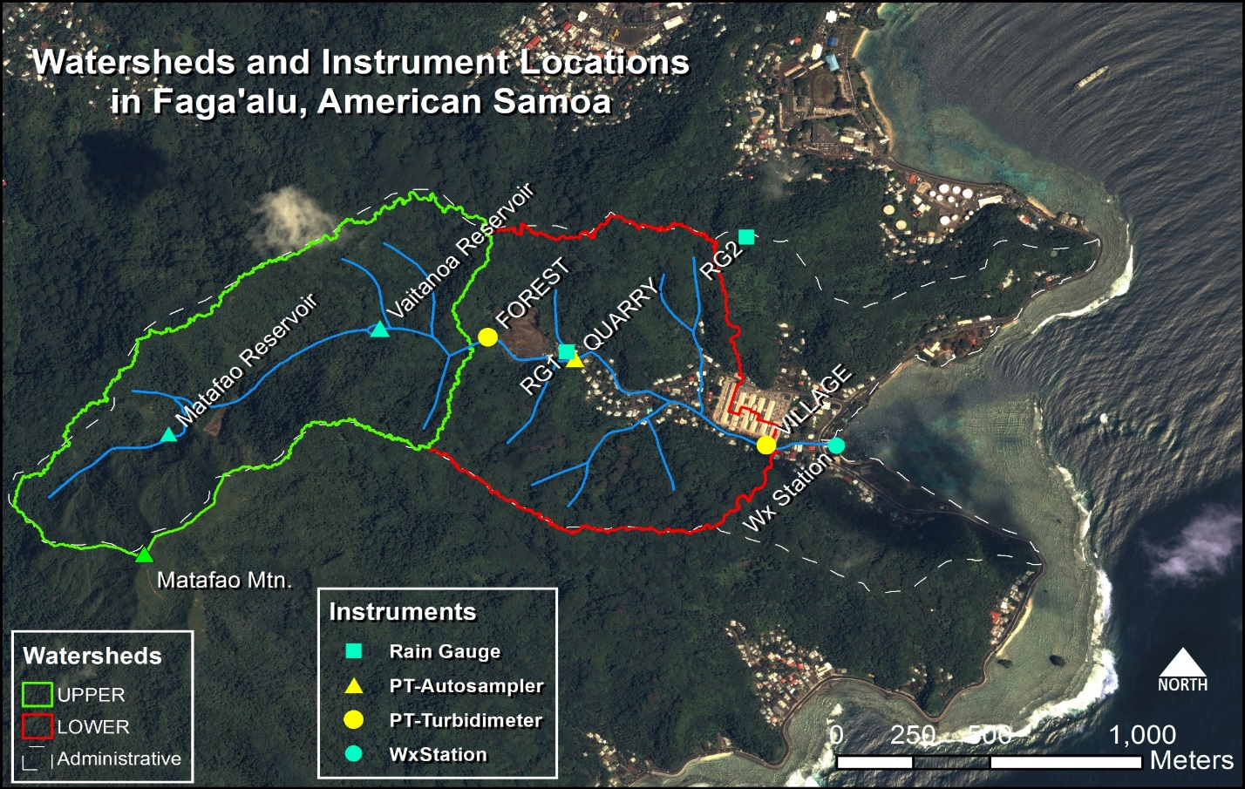

Figure 1. Location map of monitoring sites at Faga’alu. “Wx station” is a weather station with a rain gauge, wind speed, and air pressure.

1. **Streamflow monitoring**

*List of materials*

Pressure transducer (PT), SolInst Levellogger Jr, from Forestry Suppliers

Barometric pressure recorder (Weather station or SolInst Barologger)

Software and USB adapter for downloading PT data

PVC or metal pipes permanently installed at the stream

Metal ruler (“staff gage”) permanently installed in the stream

*Rationale:* Streamflow (Q, also called discharge, units in volume per time) is important for quantifying the load of sediment (Eq 1). Peak Q during storm events was a very good predictor of sediment loading from both the forest watershed and from the village watershed, so is a good way to measure the impact of mitigation by predicting the pre-mitigation SSY and observing the difference. Q is the product of the cross-sectional area of flow and the flow velocity. Since velocity across the stream can be expensive to measure, Q is often estimated using measured water depth and a mathematical relationship between the water depth and a few manual measurements of the discharge (a stage-discharge relationship). Pressure transducers (PTs) submerged at the bottom of the stream measure pressure due to both atmospheric pressure and the depth of water over the PT. The pressure due to the atmosphere is measured by a nearby barometer and subtracted from the total pressure to give the water depth. PTs are very rugged and have provided some of the most reliable data on watershed behavior at Faga’alu. Q is measured in the field with a hand-held flowmeter, by taking velocity and depth readings at intervals across the stream and calculating Q for the stream stage at that point in time. A typical Q measurement takes approximately 15-30 min and several are needed at various stream stages to develop a robust stage-discharge relationship.

*Method at Faga’alu*: PVC or metal tube housings were installed in Faga’alu Stream at FOREST (upstream of the quarry) and near the hospital (VILLAGE). A staff gage was installed on the concrete pillar of the bridge near the hospital (Figure 1). The water level on the staff gage is observed and written down in a notebook at least at the deployment and retrieval of the PT to correct for any changes in the depth of the PT when deployed. Ideally, several readings of water depth on the staff gage are taken during the PT deployment period.

A stage-discharge relationship was developed using a combination of hydraulic equations and discharge measurements to calibrate the equations. See Messina et al for more detail. The stage-discharge relationship may need updating with measurements of the cross sectional area and flow velocity if vegetation grows in the channel or if there is a lot of sediment deposited in the channel during a storm event.

1. **Suspended sediment monitoring**

*List of materials*

Turbidimeter

Turbidity standards

Bottles for collecting water from streams

Filters and vacuum filtration setup

*Rationale:* Suspended sediment concentration (SSC) is measured either directly from a water sample or indirectly using turbidity measurements. Grab samples are water samples taken directly from the stream and placed into a bottle for laboratory analysis. Lab analysis is performed by vacuum-filtering the sample onto a pre-weighed filter, drying in an oven, and weighing the dried filter and sediment. While SSC at different depths may be variable in large rivers, in small streams during storm events it is usually assumed that SSC is uniform with depth, so a grab sample provides a good measure of the average SSC. Grab samples can be taken either manually with a small bottle or with an autosampler. Autosamplers require regular maintenance like charging the battery, and the sampling tube can get clogged, but they can be automatically triggered by a water level sensor and collect critical storm measurements when field staff are unavailable. However,field staff are still needed to retrieve the samples and perform the lab analysis. As an alternative, turbidity measurements can be used to estimate SSC by developing a mathematical relationship between SSC measured in a few grab samples and a simultaneous turbidity measurement recorded by the turbidimeter.

*Method at Faga’alu*: Using a combination of grab-sampling, autosampling, and turbidimeters, SSC was measured during ~60 storm events at Faga’alu above the quarry, just below the quarry, and at the hospital (Figure 1). An autosampler was installed just downstream of the quarry, and turbidimeters were installed at the dam and at the hospital (see Messina and Biggs in prep for details).

*Analysis for impact assessment: Relationship between peak stormflow and sediment loading*

Annual totals of sediment loading are typically used to compare watersheds or assess the effectiveness of management activities. However, annual totals are influenced by the natural variability in number and intensity of storm events and natural erosion. The relationship between streamflow and suspended sediment concentration can be used to show a decrease in sediment at the same streamflow, however, this relationship is highly variable in many streams, and could not be used in Faga’alu.

It can be difficult to interpret sediment concentrations in terms of impact of management activities without the context of storm events because sediment concentration varies widely with streamflow and naturally occurring erosion. Is sediment concentration high because of some management activity upstream, or because a sample was taken during a storm event when concentrations may be naturally high? Similarly, the load is highly dependent on streamflow.

The impact of streamflow on sediment concentration and loads can be controlled for by plotting different metrics of streamflow (e.g. peak discharge, streamflow at a given time, total stormflow volume, etc) against total sediment load to the stream. We found that there is no simple relationship between streamflow and sediment concentration, because that relationship changes depending on whether you sample the rising or falling limb of the stormflow hydrograph. Therefore, we used total storm loading of sediment (tons per event) versus peak stormflow (Qpeak) (Figure xx). A management impact would be demonstrated by a change in the Qpeak-sediment load relationship.

*Continued monitoring recommendations*

We anticipate that at least 10 storms will need to be measured in order to establish any change in the Qpeak-sediment load relationship. Storm sampling includes taking at least 5 samples per storm, at 5-30 minute intervals. Care should be taken to sample on the rising limb and peaks, since that is when concentrations are highest.

1. SEDIMENTATION IN THE BAY

*List of materials*

PVC tubes (2”)

SedPods (N=9)

*Rationale for monitoring sedimentation*

Sediment discharged from the watershed may or may not affect the reef depending on ocean conditions. If sediment discharge happens during a time of intense ocean circulation, deposition may be much lower than during times of quiescent ocean conditions. Therefore, monitoring of sedimentation rates on the reef itself is important to determine the ultimate impact of management activities on a reef.

*Key metric: Sedimentation rates in tubes and on SedPods*

Two aspects of sedimentation are important for corals:

1. Gross accumulated sediment deposition. This is measured by PVC tubes, which capture all sediment that enters them and prevents the sediment from getting washed away.
2. Net sediment deposition, accounting for sediment getting resuspended and washed away. This is measured using concrete SedPods, which are exposed to waves and currents, allowing sediment to get washed away.

The tubes are constructed from 2” PVC pipe with an end cap. SedPods are constructed from 6-inch diameter PVC pipe filled with concrete. The concrete is poured on rough plywood to give it texture to approximate the rough texture of coral reef. Sediment is collected monthly by trained SCUBA divers, and analyzed in the laboratory for sediment weight, grain size, and composition. Details on sediment collection are in the QAPP.

*Key metric: Sediment characteristics: Fine/coarse fractions and terrestrial vs carbonate fraction*

The impact of sediment on coral may depend on the sediment size, and the fraction of the sediment that is terrestrial vs marine in origin. We anticipate that the fine fraction and terrestrial fractions will decrease with reduced loading from the watershed. The fine-coarse faction can be determined with simple laboratory equipment, but the methods must be followed very carefully to be consistent with other results. The terrestrial fraction is determined using combustion of the calcium carbonate in an oven (see QAPP for details).

**Baseline values**

*Stream sediment concentrations and loads:*

High concentrations of sediment were observed in 2012 during baseflow conditions (Figure 2), which we believe was due to in-stream construction activity (bridge) and to mining operations between storms. Both activities have since stopped, and high concentrations are no longer observed between storms, with some exceptions (see Quarry 2014).

The scatter in the Q-SSC relationship (Figure 2) means that it is not a good way to determine the success of management activities. Instead, there was a regular relationship between total storm sediment load and total storm rainfall, total stormflow, and peak storm flow (Qpeak) (Figure 3).  *We believe that Qpeak can be used to estimate the pre-mitigation sediment load, and compared to future measurements to quantify the impact of management on sediment mitigation.*

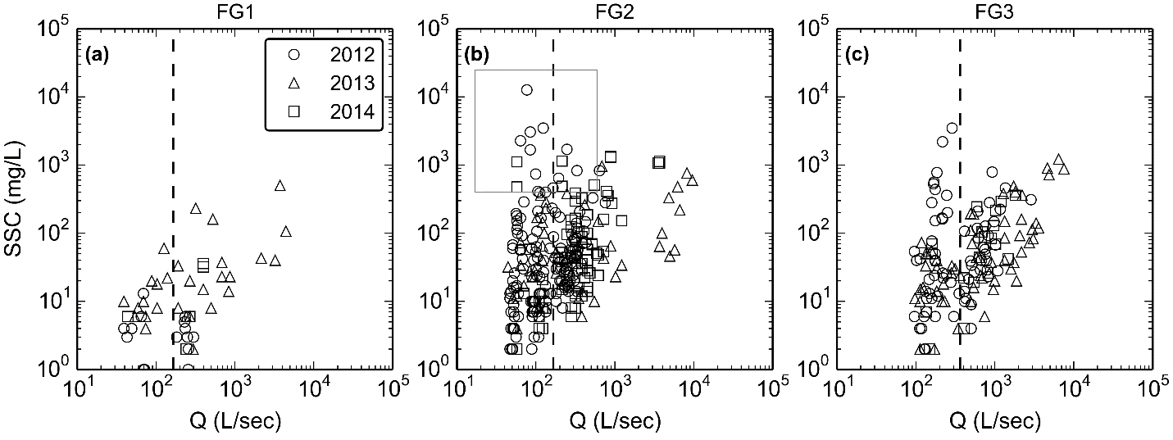

*Figure 2. Discharge (Q) versus suspended sediment concentration (SSC, mg/L) at the (a) forest, (b) quarry, and (c) village sites. The box in (b) highlights where SSC was high during low streamflow, downstream of the quarry, and then slightly diluted downstream near the hospital (c). These were notably absent from the forest site (a), and are hypothesized to be caused by activities at the quarry that ceased after 2012, i.e. washing sediment from the crushed aggregate during non-storm periods, and remediation of groundwater flow eroding sediment from haul surfaces.*

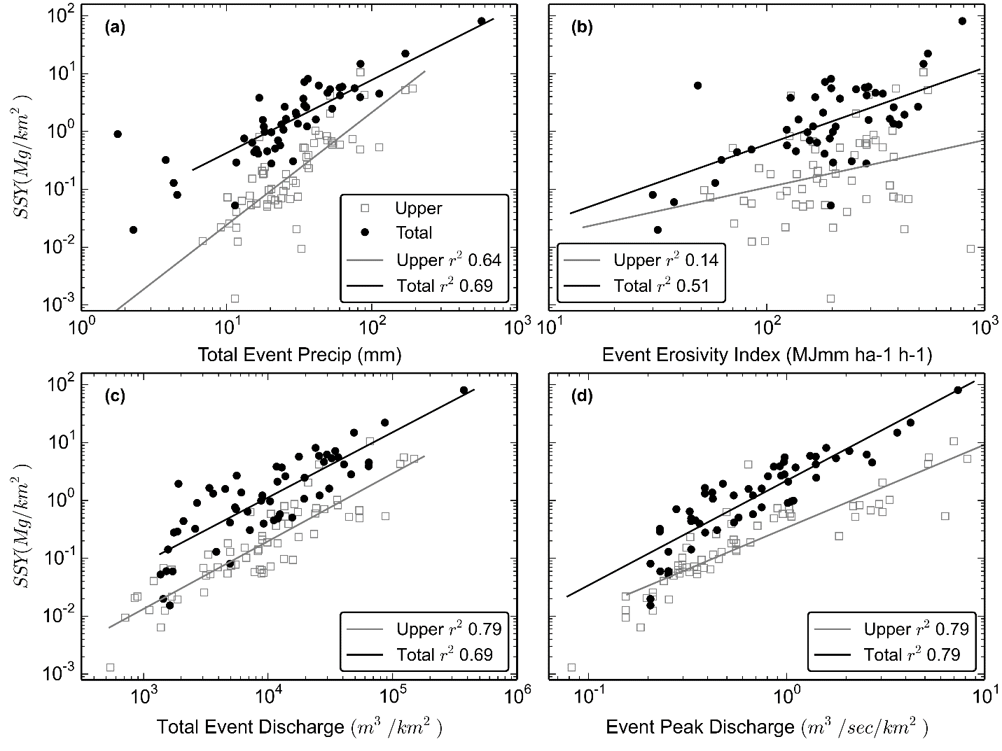

*Figure 3. Storm event* *sediment yield (tons/km2) from the Upper watershed (undisturbed forest), and the Total watershed (including the quarry and village), versus (a) rainfall, (b) rainfall erosivity, (c) event discharge, and (d) event peak discharge. The model for the disturbed Total watershed is higher than the model for undisturbed Upper watershed, indicating human disturbance in the quarry and village has increased SSY above natural levels. Qpeak (d) showed the best model fit (r2 = 0.79) for both the Upper and Total watersheds. This model can be used to predict pre-mitigation SSY and compare to post-mitigation SSY, illustrating the effectiveness of mitigation. By reducing SSY through mitigation at the quarry, SSY measured during storms post-mitigation should plot on the model for the Upper watershed, indicating SSY from the watershed is back to the natural baseline SSY.*

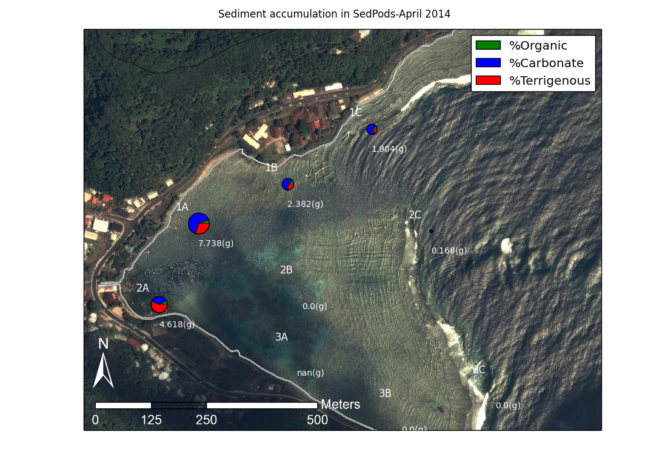

*Figure 4. Map showing locations of sedpods + tubes, sample plots with amounts, carbonate vs terrestrial fraction.*

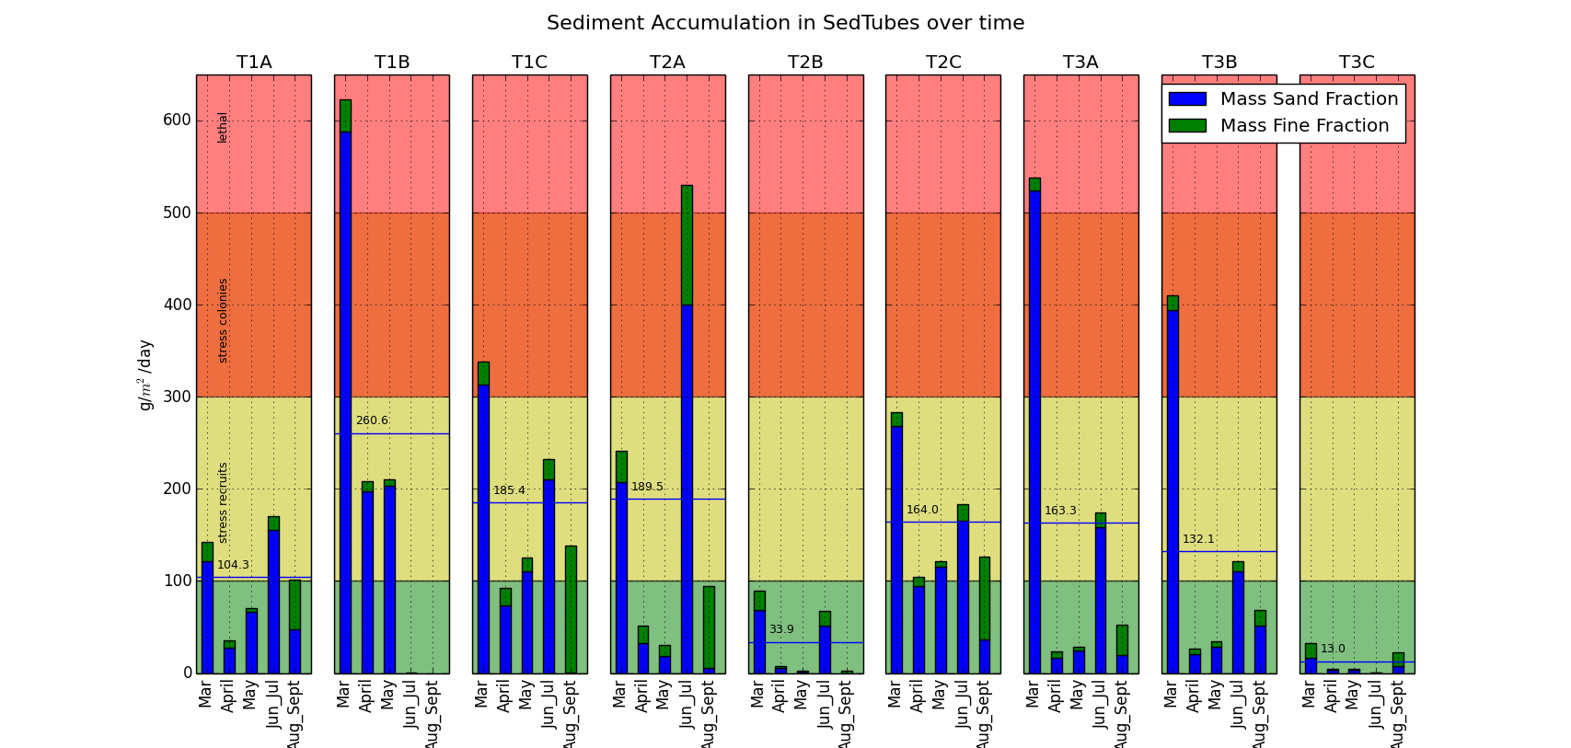

*Figure 5. Time series of sediment accumulation in the tubes, March 2014-August 2014.*

**Outlook: Anticipated changes due to mitigation activities**

We expect that the mitigation activities at the quarry will have immediate impacts on sediment loading. Prior to the installation of the two sediment retention basins, surface flow in the quarry was diverted from the stream and into a settling pond on the quarry premises. Coincident with this activity, the sediment concentration decreased during baseflow downstream of the quarry, and the extremely high SSC values observed in 2012 were not observed following the mitigation of flow (Figure 2). Preliminary observations suggest that the retention basins successfully retained runoff and sediment generated at the quarry, resulting in immediate qualitative improvement of stream turbidity. Results from sampling in 2014 will provide quantitative estimates of those impacts for several storms.

The main long term challenge will be to maintain the retention capacity of the ponds. Ponds fill up with both water and sediment, and their effectiveness will deteriorate between cleanings. There may be reduced retention capacity particularly after large events. Proper maintenance of the ponds is essential for continued effectiveness of the ponds as tools for sediment mitigation.

The impact of reduced sediment loading on sedimentation rates observed in the bay is more uncertain and may have a temporal lag of several years to a decade. Sediment in reefs systems can have residence times of years to decades or more, and resuspension of those sediments can result in continued turbidity and deposition on the SedPods and reef. We do anticipate that the terrigenous fraction will decrease after the mitigation activities, possibly more quickly than the reduction in sedimentation rates.

**Section 2. Comprehensive baseline assessment of coral reef community structure and demographics in Faga`alu Bay, American Samoa**

Bernardo Vargas-Ángel

**Significance**

The reef at Faga’alu Bay, American Samoa, is severely affected by siltation stress, due to excessive terrigenous runoff resulting from prolonged and deficient land use practices within the boundaries of the adjacent watershed. Additional secondary impacts to reef corals and associated communities in the Bay include nutrient loading (nitrogen and phosphorus), lowered levels of dissolved oxygen, and elevated bacterial counts from urbanization and inadequate waste management. By documenting coral reef benthic community structure and demographic parameters in a spatially comprehensive manner, this work provides baseline information that is critical to evaluate the effectiveness of reef-to-ridge management practices aimed at reducing land-based sources of pollution threats in Faga’alu Bay, American Samoa. This information is also of use as the basis to track and improve water quality, enhance ecosystem resilience, and update coral reef protection measures.

**Methods**

A stratified random sampling design was implemented to survey the study sites; the survey domain encompassed ~90% of the mapped area of reef and hard bottom habitat, which was divided into four strata based on reef zone (backreef and forereef) and location (north and south). Allocation of sampling effort was relative to strata area and sites were randomly selected within each stratum. Rapid ecological assessments, totaling surveys at 40 sites (Fig 1) were conducted between March 2012 and April 2013 by staff of NOAA’s Coral Reef Ecosystem Division (CRED), with three sites marked permanently for future visits and reassessments.

*Figure 1 –Location of the benthic sites surveyed at Faga’alu Bay, American Samoa, between March 2012 and April 2013. Backreef sites indicated in orange and forereef sites indicated in yellow. Red symbols indicate permanent sites; 2 backreef and 1 forereef. All sites were selected using a stratified random design.*

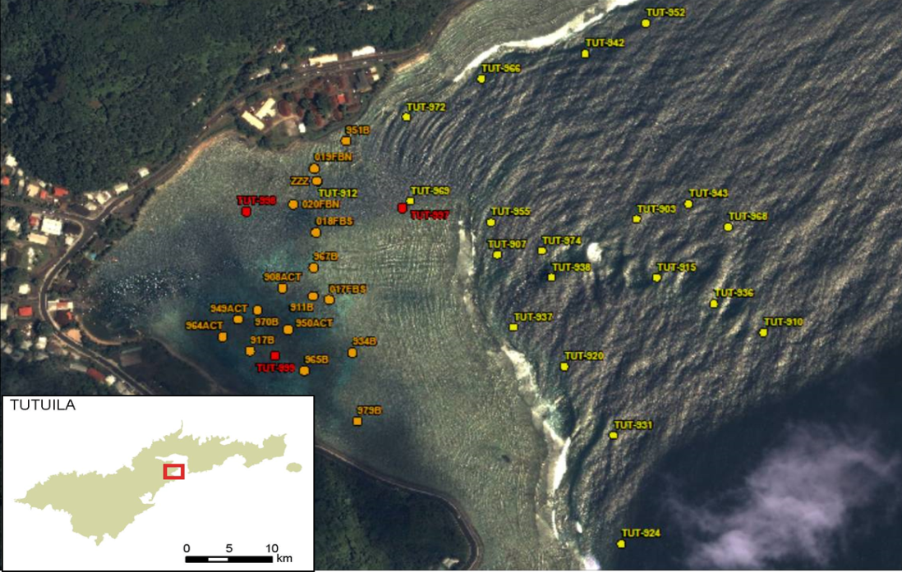

At each site, the belt-transect method, with two 25-m transect lines as the focal point of the survey was implemented to quantitatively assess benthic community structure and demographics. Along each transect, five 2.5-m2 segments were surveyed (0–2.5 m; 5.0–7.5 m; 10–12.5 m; 15–17.5 m; 20–22.5 m), whereby all coral colonies whose center fell within 0.5 m on either side of each transect line were identified to the highest level possible of taxonomic resolution and measured for two planar size metrics: maximum diameter and diameter perpendicular to the maximum diameter (NOAA 2015). Coral recruits (defined as attached colonies smaller than 5 cm in diameter) were also quantified, measured, and identified to the highest possible level of taxonomic resolution. For each coral colony identified within belt-transect surveys, the extent of mortality –both recent and old, were estimated, dedicating special attention to any evidence of sediment-related damage or stress. In addition, the Line-Point-Intercept methodology at 25 cm intervals was implemented to derive information on percent benthic composition, relative abundance, and cover (NOAA 2015).

*Analysis of benthic community structure and demographics data*

Spatial patterns of mean percent coral cover and colony densities were tested implementing independent two-way ANOVA models, using reef zone (backreef vs. forereef) and location (north vs. south) as factors. Cover data was ln-transformed to fulfill parametric statistical requirements.

**Baseline values**

*Benthic composition and community structure*

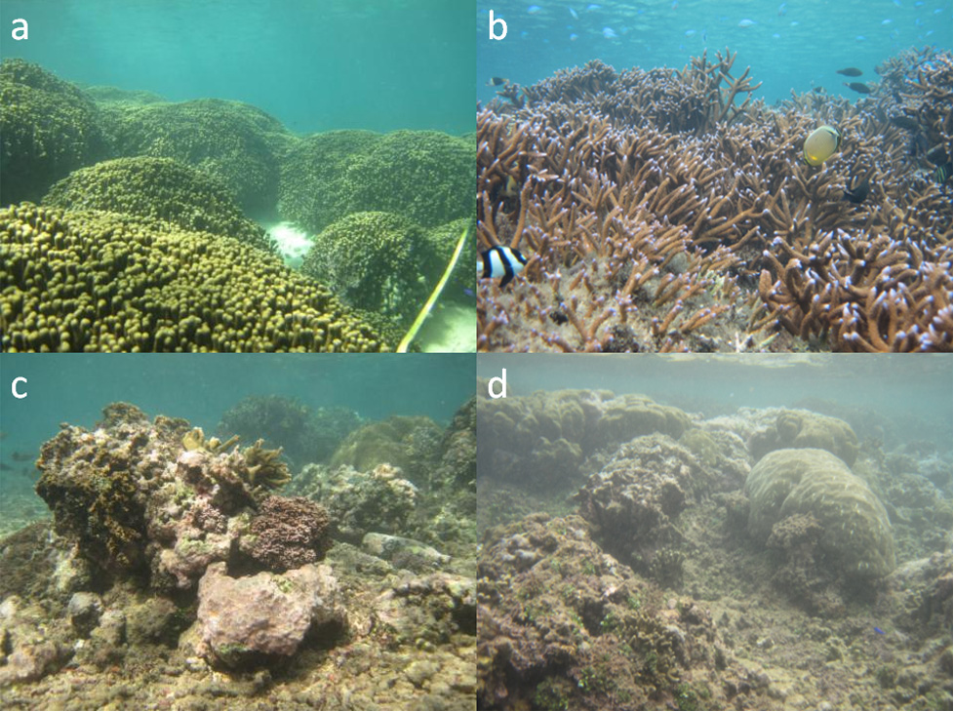

**Figure 2** –*Visual, spatial comparison of coral growth, development, and appearance of shallow habitats of the (a) south, (b) central, and (c, d) northern areas of the backreef in Faga`alu Bay, American Samoa. NOAA photos by Bernardo Vargas-Ángel.*

The quantitative survey data support the benthic community patterns that previously had been anecdotally reported and observed in the field: coral development is conspicuously prominent along the central and southern portions of the reef in Faga`alu Bay (Fig. 2a, b), compared to the northern areas, where coral growth is quite limited and depauperate (Fig. 2c, d).

Mean percent live coral cover was nearly twice as high along the southern area of the reef compared to the northern sector (Fig. 3a) and those differences were significant; differences between forereef and backreef were non-significant (two-way ANOVA, FLOCATION=9.43, df=1, P=0.004; FREEFZONE=0.96, df=1, P=0.33), with no interaction effects between factors (two-way ANOVA, FREEFZONE × LOCATION=0.49, df=1,1, P=0.48). Levels of crustose coralline algae were not distinctly different between the northern and southern sectors of the reef (Fig. 3b) (two-way ANOVA, FLOCATION=1.30, df=1, P=0.26; FREEFZONE=9.34, df=1, P=0.004)., and percent cover of turf algae was significantly different between reef zones and location; no factor interaction effects however (two-way ANOVA, FLOCATION=7.76, df=1, P<0.009; FREEFZONE=11.19, df=1, P=0.002)(Fig. 3c). The northern areas of the reef in Faga`alu Bay are directly affected by terrigenous siltation and runoff. Surveys corroborate this appraisal, as exemplified by the “reef-builder ratio,” which is the proportion of corals and crustose coralline algae to non-accreting organisms (macroalgae and turfalgae) calculated with values of mean percent cover. The reef-builder ratio was greater along the southern backreef and forereef than along the coral-impoverished northern reef and those differences were statistically significant (two-way ANOVA, FLOCATION=11.22, df=1, P<0.002; FREEFZONE=1.49, df=1, P=0.23) (Fig. 3d).

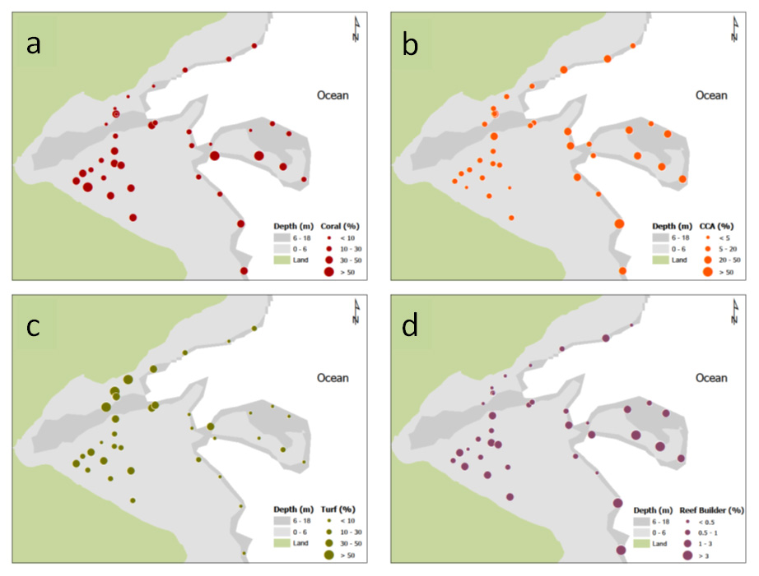

Figure 3 –*Spatial comparison of mean cover (%) values for (a) live hard corals, (b) crustose coralline algae (CCA), (c) turf algae, and (d) values of the reef-builder ratio (ratio of mean cover for corals and crustose coralline algae combined to cover for non-accreting organisms) from line-point-intercept surveys conducted in March 2012 and April 2013 in Faga`alu Bay.*

*Colony densities and condition*

Figure 4a illustrates estimates of coral colony density of 6 important reef-building coral genera in Faga`alu Bay. Overall colony densities were higher along the southern backreef and forereef (13.44 colonies/m2, SE 0.99) than along the northern sector of the reef (9.34 colonies/m2, SE 1.70), and these differences were statistically significant (two-way ANOVA, FLOCATION=5.11, *df*=1, P=0.03). Although differences between reef zones were statistically non-significant (two-way ANOVA, FREEFZONE=2.44, *df*=1, P=0.12, there was an interaction effect between factors, indicating a clear segregation of the four strata when considering reef location. Additional differences in coral generic composition and density were evident: corals of the genus *Porites* were heavily dominant along the shallow northern backreef while corals of the genus *Montipora* occurred primarily along the channel and southern forereef. Additional notable spatial and structural differences indicated a preponderance of encrusting and foliose corals of the genera *Montipora* and *Pavona*, respectively, along the shallow northern backreef and, in contrast, the presence of branching corals of the genus *Acropora* throughout the southern backreef; encrusting and foliose species that appeared to tolerate the lower levels of light and conditions of higher turbidity prevalent on the northern backreef (see Rodgers 1990; Crabbe and Smith 2005). Differences among habitats also were observed in values of coral generic richness (Fig 4b), with a greater mean number of genera occurring along the deeper forereef (10.95, SE 0.67) compared to the shallow backreef (6.29, SE 0.25), and these differences also were statistically significant (*P*=0.001, Student’s *t*-test). Such variation is expected given the disparate range of environmental conditions (for example, light, depth, water circulation) and of available microhabitats present on the forereef compared to the shallow, relatively homogeneous backreef.

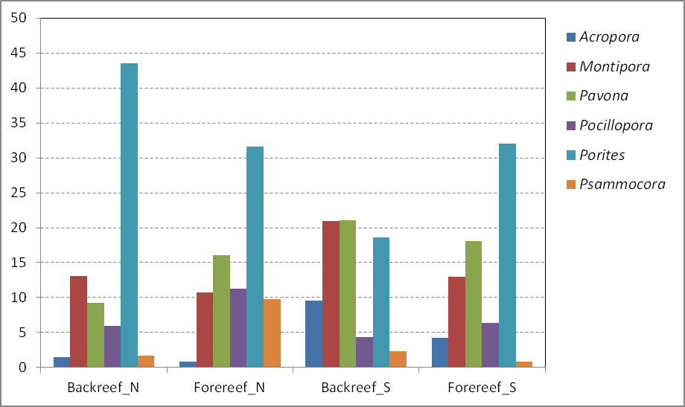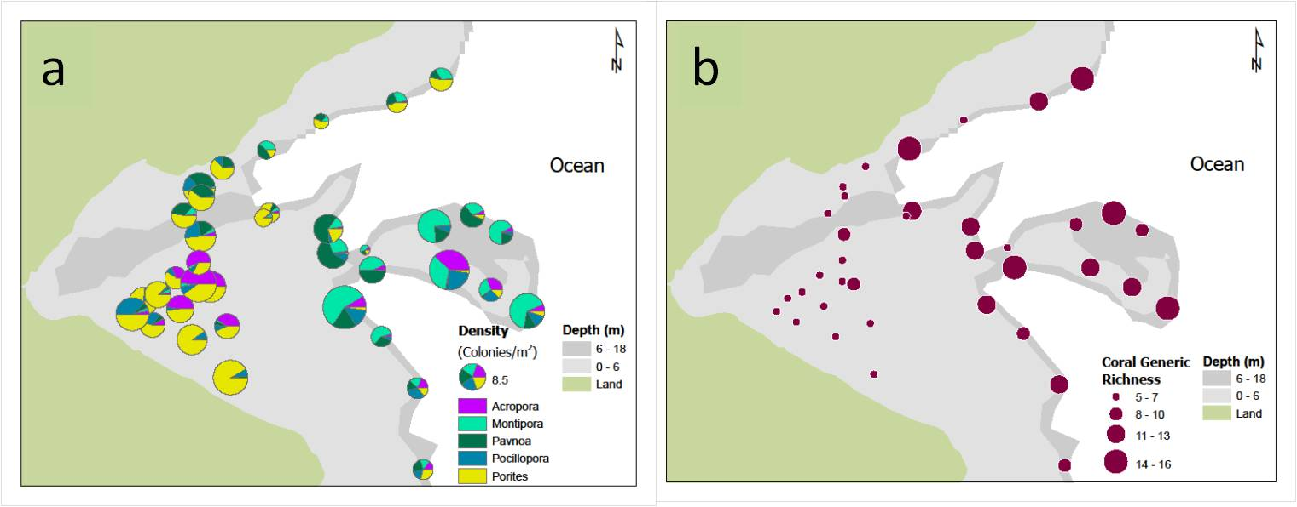

Figure 4 –*Spatial comparison of (a) coral-colony density (colonies/m2) and (b) total coral generic richness from belt-transect surveys conducted in March 2012 and April 2013 in Faga`alu Bay. The color-coded bars indicate densities of selected dominant coral genera.*

a

Except for one site on the southern backreef, low levels of bleaching were commonplace across habitats and depths in Faga`alu Bay (Fig. 5). Similarly, mean prevalence of coral disease was low (0.1%, SE 0.02) overall; however, non-tissue loss lesions resulting in compromised health were greater at north-facing backreef sites (077%, SE 0.39) than at south-facing sites (0.62%, SE 0.12). Although small, these differences could be associated with the elevated, chronic terrigenous runoff and sedimentation that affects these areas.

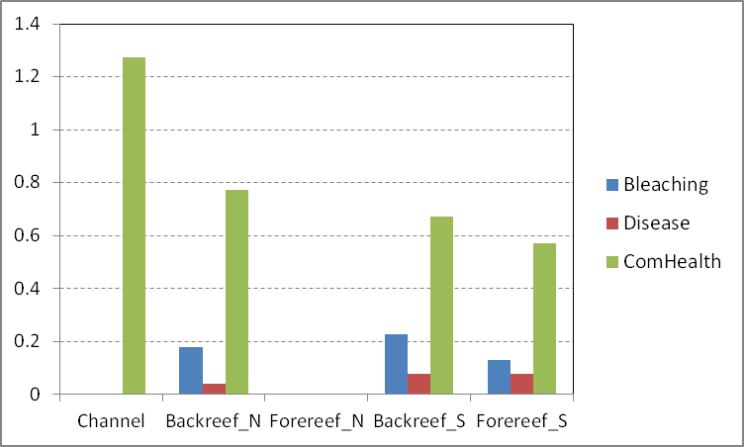

Figure 5 –*Spatial comparison of prevalence (%) of bleaching, disease from belt-transect surveys conducted in March 2012 and April 2013 in Faga*`*alu Bay.*

**Outlook: Anticipated changes due to mitigation activities**

In actively growing coral reefs, calcifying organisms—corals, crustose coralline algae, and other calcifying plants—typically dominate coral communities. In contrast, communities dominated by noncalcifiers, such as turf algae, cyanobacteria, and other macroalgae, are common in areas with suboptimal. Impacts to the benthic communities in Faga’alu Bay, particularly corals, result from the combined effects of increased turbidity, sedimentation, and nutrient influx. Although upslope quarry mitigation activities are expected to result in changes to the composition and structure of the adjacent coral reef benthos, the spatial and temporal constructs of these changes, may observe protracted lags ranging from years to decades.

Turf and macroalgal communities promptly respond to changes in nutrient influx, thus, it can be speculated that the first signs of change may be quantifiable as reductions in the cover of these benthic elements. However, because corals exhibit a lesser competitive superiority compared to algae, their recovery will depend on the reduction of the algal populations, together with improvement of water clarity, the reduction of nutrient inputs, as well as the availability and establishment of recruits.

Herbivore grazing is also fundamental to reef recovery because it exerts control over algal populations, which in turn has direct effects on the development of corals assemblages and other calcifying taxa such as coralline algae. The preservation of healthy fish and invertebrate herbivores will be pivotal to the reestablishment of functional coral communities, particularly those along the northern portion of the reef which exhibit the greatest levels of siltation impact.

Lastly, the historical landfill located on the current school site (northern Bay) is a potential source of contaminants, particularly arsenic, which may preclude, or delay the recovery of shallow benthic assemblages on this side of the fringing reef.

**References**

Rodgers CS.

1990. Responses of coral reefs and reef organisms to sedimentation. Mar Ecol Prog Ser 64:185–202.

[Crabbe](http://www.springerlink.com/content/?Author=M.+James+C.+Crabbe) MJC, [Smith](http://www.springerlink.com/content/?Author=David+J.+Smith) DJ.

2005. Sediment impacts on growth rates of *Acropora* and *Porites* corals from fringing reefs of Sulawesi, Indonesia. Coral Reefs 24:437–441.

NOAA

2015. Pacific Islands Fisheries Science Center, Coral Reef Ecosystem Division, Survey Methods. Available at: <http://www.pifsc.noaa.gov/cred/survey_methods.php#benthic_monitoring_rea>. Accessed January 2015.

**Section 3.**

**Pollution in Surface Sediments of Faga’alu Bay and Watershed, American Samoa**

David Whitall

**Significance**

Despite their ecological, economic and cultural value, over half of the world’s coral reefs are threatened by human activity (Bryant *et al.*, 1998). Increased runoff of sediment, nutrients, and pollutants has been correlated to the degradation of coral reefs (Fabricius, 2005). Although pollution is a known cause of the decline of coral reefs, details of the relationship between contaminants and corals are not well understood. There are currently no established thresholds for individual pollution stressors indicating concentration limits above which corals are harmed.

This study presents a baseline assessment of the magnitude and spatial distribution of pollution in the coral reef ecosystem of Faga’alu Bay. This information will provide ecosystem managers a reference point against which to evaluate the success of upland watershed best management practices.

*Providing Context for Results*

In addition to comparing contamination results between strata, these findings can be compared to previously published numerical sediment quality guidelines (SQG) known as ERL (effects range-low) and ERM (effects range-median) developed by Long and colleagues (Long and Morgan, 1990; Long *et al*., 1995, Long et al. 1996, Long et al. 1998, Long and MacDonald, 1998). For the purposes of discussion, when a sample exceeds the ERM, toxicity to benthic infauna is said to be probable. When a sample exceeds the ERL but not the ERM, toxicity to benthic infauna is possible. It should be noted that SQG were designed for marine systems, so they are not directly applicable to freshwater stream sites. Stream sites are included here purely for reference. It is also important to note that SQG do not consider the additive impact of multiple pollutants on organisms.

**Methods**

1. SAMPLING DESIGN

A stratified random sampling design allowed this study to assess the overall contaminant condition of the ecosystem, and to be able to make geographically explicit conclusions about how pollutants vary spatially. In this method, all areas within a stratum had an equal chance of being selected as a sampling site. The four strata were: Inner Bay, South Bay, North Bay and Channel. Additionally, four targeted sediment sites were selected in the watershed and one targeted site was sampled near the school/landfill. A total of seventeen sediment sites were sampled in January of 2014.

1. FIELD SAMPLING

Sediment samples were collected using standard NOAA National Status and Trends (NS&T) Program protocols (Lauenstein and Cantillo, 1998). Briefly, surface sediment samples (top 2 cm) were collected directly into certified pre-cleaned HPDE 250 ml jars. Field personnel wore disposable nitrile gloves to prevent cross contamination between sites. Jars were stored on ice while in the field, then kept frozen until analysis.

1. LABORATORY ANALYSES

Sediment samples were analyzed via standard NS&T techniques at the NS&T contract lab (TDI Brooks International, College Station, Texas). Detailed analytical methods can be found in Kimbrough *et al.* 2006 and Kimbrough and Lauenstein 2006. Briefly, PAHs were analyzed in the laboratory using gas chromatography/mass spectrometry in the selected ion monitoring (SIM) mode (Kimbrough *et al.* 2006). Selected chlorinated organics (PCBs and pesticides) were analyzed using gas chromatography/electron capture detection (Kimbrough *et al.* 2006). Butyltins were analyzed using gas chromatography/flame photometric detection (Kimbrough *et al.* 2006).

Silver, cadmium, copper, lead, antimony, and tin were analyzed using inductively coupled plasma - mass spectrometry. Aluminum, arsenic, chromium, iron, manganese, nickel, silicon and zinc were analyzed using inductively coupled plasma - optical emission spectrometry. Mercury was analyzed using cold vapor - atomic absorption spectrometry. Selenium was analyzed using atomic fluorescence spectrometry (Kimbrough and Lauenstein et al. 2006). For each element, total elemental concentration (i.e. sum of all oxidation states) was measured.

Data Analysis

**Baseline Values and Key Findings**

In general, pollution in Faga’alu Bay is relatively low. The ERM sediment quality guidelines were exceeded only for nickel (1 site in the watershed and 1 site in the Inner Bay) and zinc (1 site in the watershed). This suggests probable toxicity to benthic infauna at these sites. The ERL but not the ERM guideline was exceeded for at least one site for the following analytes: silver, arsenic, chromium, copper, zinc, nickel, chlordane and PCBs (Table 1). This suggests that there is the possibility of toxicity to sediment infauna at these sites. Most analytes are higher in the watershed than in the Bay, suggesting a terrestrial source (e.g. Figure 1). An exception to this is arsenic where the highest value was measured in the North Bay strata (Figure 2). This may be related to the historical land fill located on the current school site. Metals quantified in this study are generally well correlated with crustal elements that are generally not considered to be pollutants (e.g. Al, Fe, Mn, Si). This is particularly true for Zn (Figure 3) and Ni, meaning that despite their relatively elevated sediment concentrations, these levels are likely natural and the product of the erosion of watershed bedrock material. Conversely, arsenic (Figure 4) is not well correlated with other crustal elements (Figure 4). Legacy organic contaminants (e.g. chlordane, DDTs, PCBs) found in the Bay are likely due to their widespread historical use and environmental persistence, rather than any new sources of those pollutants in the system.

This data set serves as an important baseline against which to measure future change, including the efficacy of ongoing watershed management activities (e.g. improved management practices at the quarry). Although Faga’alu Bay is not especially polluted with toxic contaminants, there are some reasons for concern, including potential leaching of metals and organics from the legacy landfill on the north shore of the Bay. Furthermore, crustal element loads may decrease following changes in management practices at the quarry, which could be quantified with future sampling.

**Outlook: Anticipated changes due to mitigation activities**

Additional Information

More detailed analysis, including maps, graphs and statistics will be available in a published NOAA technical memorandum (scheduled publication date May 2015). Please contact Dr. David Whitall ([dave.whitall@noaa.gov](mailto:dave.whitall@noaa.gov)) with technical questions.

References

Bryant, D., Burke, L., McManus, J., Spalding, M. *Reefs at Risk: A Map-based Indicator of Threats to the World’s Coral Reefs*. World Resources Institute, Washington, DC, 1998.

Fabricius, K.E.. Effects of terrestrial runoff on the ecology of corals and coral reefs: review and synthesis. 2005. *Mar. Poll. Bull.,* 50, 125–146.

Kimbrough, K.L. and G.G. Lauenstein (eds). 2006. Major and trace element analytical methods of the National Status and Trends Program: 2000-2006. Silver Spring, MD. NOAA Technical Memorandum NOS NCCOS 29. 19 pp.

Kimbrough, K.L., G.G. Lauenstein and W.E. Johnson (eds). 2006. Organic contaminant analytical methods of the National Status and Trends Program: Update 2000-2006. NOAA Technical Memorandum NOS NCCOS 30. 137 pp.

Lauenstein, G.G., and Cantillo, A.Y. (1998). Sampling and Analytical Methods of the National Status and Trends Program Mussel Watch Project: 1993-1996 Update. U.S. Dept. Comm., NOAA Tech. Memo. 130, NOS ORCA, Silver Spring, Maryland.

Long, E.R. and Morgan, L.G. 1990. The Potential for Biological Effects of Sediment-Sorbed Contaminants Tested in the National Status and Trends Program. NOAA Tech. Memo NOS OMA 52. NOAA, Seattle, WA. 175 pp.

Long, E.R., MacDonald, D.D., Smith, S.L., and Calder, F.D. 1995. Incidence of adverse biologival effects within ranges of chemical concentrations in marine and estuarine sediments. *Environmental Management* 19: 81-97.

Long, E.R., Robertson, A., Wolfe, D.A., Hameedi, J. and Sloane, G.M. 1996. Estimates of the spatial extent of sediment toxicity in major U.S. estuaries. *Environmental Science and Technology* 30(12):3585-3592.

Long, E.R., L.J. Field and D.D. MacDonald. 1998. Predicting toxicity in marine sediments with numerical sediment quality guidelines. *Environmental Toxicology and Chemistry* 17(4): 714-727.

Long, E.R., and D.D. MacDonald. 1998. Recommended uses of empirically derived, sediment quality guidelines for marine and estuarine ecosystems. *Human and Ecological Risk Assessment* 4(5): 1019-1039.

Table 1: Summary statistics for sediment samples in Faga’alu Bay and watershed (January 2014). Summary statistics include targeted (e.g. watershed) sites.

|  |  |  |  |  |  |  |  |
| --- | --- | --- | --- | --- | --- | --- | --- |
| **Analyte** | **Units** | ***Min*** | ***Max*** | ***Mean*** | ***Median*** | ***StDev*** | ***Number of Sites Exceeding ERL/ERM*** |
| **Ag** | ug/g | 0 | 2.74 | 0.49 | 0 | 0.81 | 4/0 |
| **Al** | ug/g | 475 | 72400 | 25682 | 8250 | 28817 | NA |
| **As** | ug/g | 1.19 | 11.5 | 4.44 | 3.91 | 2.90 | 3/0 |
| **Cd** | ug/g | 0 | 0.31 | 0.10 | 0.07 | 0.09 | 0/0 |
| **Cr** | ug/g | 7.13 | 191 | 39.47 | 25.7 | 46.42 | 1/0 |
| **Cu** | ug/g | 0 | 37.7 | 8.53 | 5.74 | 9.67 | 1/0 |
| **Fe** | ug/g | 712 | 103000 | 28484 | 18300 | 29827 | NA |
| **Hg** | ug/g | 0.000764 | 0.0163 | 0.01 | 0.01 | 0.00 | 0/0 |
| **Mn** | ug/g | 20 | 1250 | 467 | 184 | 495 | NA |
| **Ni** | ug/g | 4.19 | 211 | 35.13 | 12.6 | 50.66 | 4/2 |
| **Pb** | ug/g | 0.641 | 45.5 | 13.15 | 8.46 | 12.93 | 0/0 |
| **Sb** | ug/g | 0 | 0.472 | 0.18 | 0.196 | 0.15 | NA |
| **Se** | ug/g | 0 | 0.127 | 0.02 | 0 | 0.04 | NA |
| **Si** | ug/g | 105 | 256000 | 74608 | 13300 | 97244 | NA |
| **Sn** | ug/g | 0.27 | 15.40 | 4.50 | 4.37 | 3.73 | NA |
| **Zn** | ug/g | 3.70 | 416.00 | 109.69 | 53.70 | 119.72 | 3/1 |
| **Total PAHs** | ng/g | 1.35 | 2097.48 | 177.80 | 27.49 | 501.36 | 0/0 |
| **Total HCH** | ng/g | 0 | 0.10 | 0.03 | 0 | 0.04 | NA |
| **Total Chlordane** | ng/g | 0 | 4.60 | 0.62 | 0 | 1.30 | 5/0 |
| **Total DDT** | ng/g | 0 | 2.29 | 0.23 | 0.11 | 0.54 | 1/0 |
| **Total PCBs** | ng/g | 2.19 | 92.89 | 14.35 | 2.32 | 29.06 | 3/0 |
| **Monobutyltin** | ng/g | 0 | 2.00 | 0.18 | 0 | 0.54 | NA |
| **Dibutyltin** | ng/g | 0 | 0.60 | 0.08 | 0 | 0.17 | NA |
| **Tributyltin** | ng/g | 0 | 0.98 | 0.07 | 0 | 0.24 | NA |
| **Tetrabutyltin** | ng/g | 0 | 0 | 0 | 0 | 0 | NA |
| ***Clostridium perfringens*** | CFU/g | 0 | 1722 | 302 | 125 | 432 | NA |

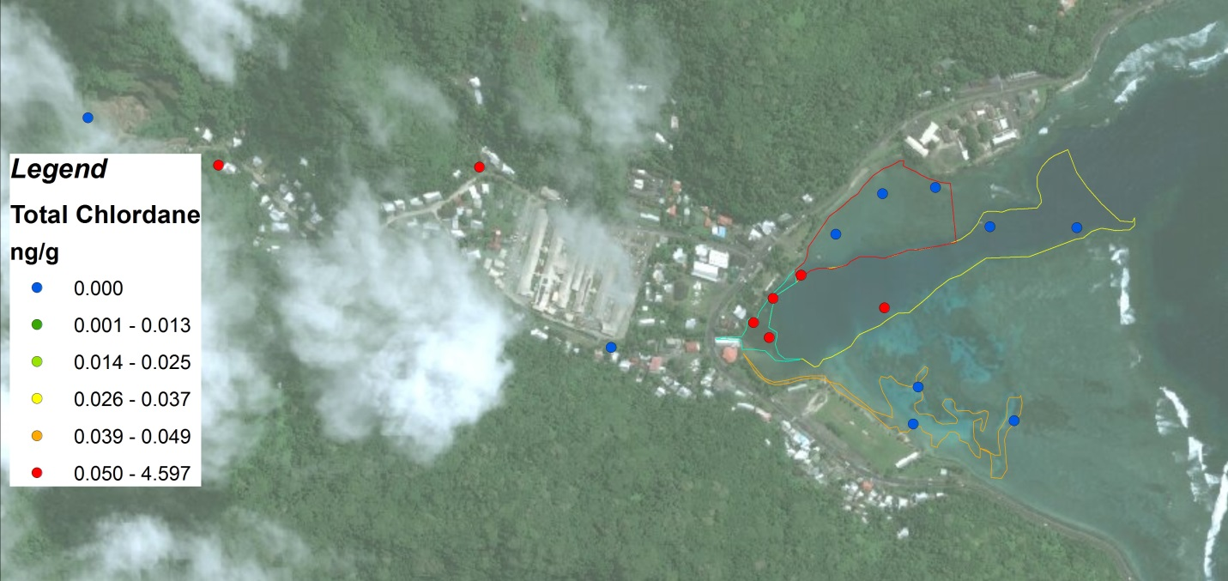

Figure 1: Total chlordane concentrations in sediments (January, 2014). This is a representative figure showing a strong watershed pollutant source.

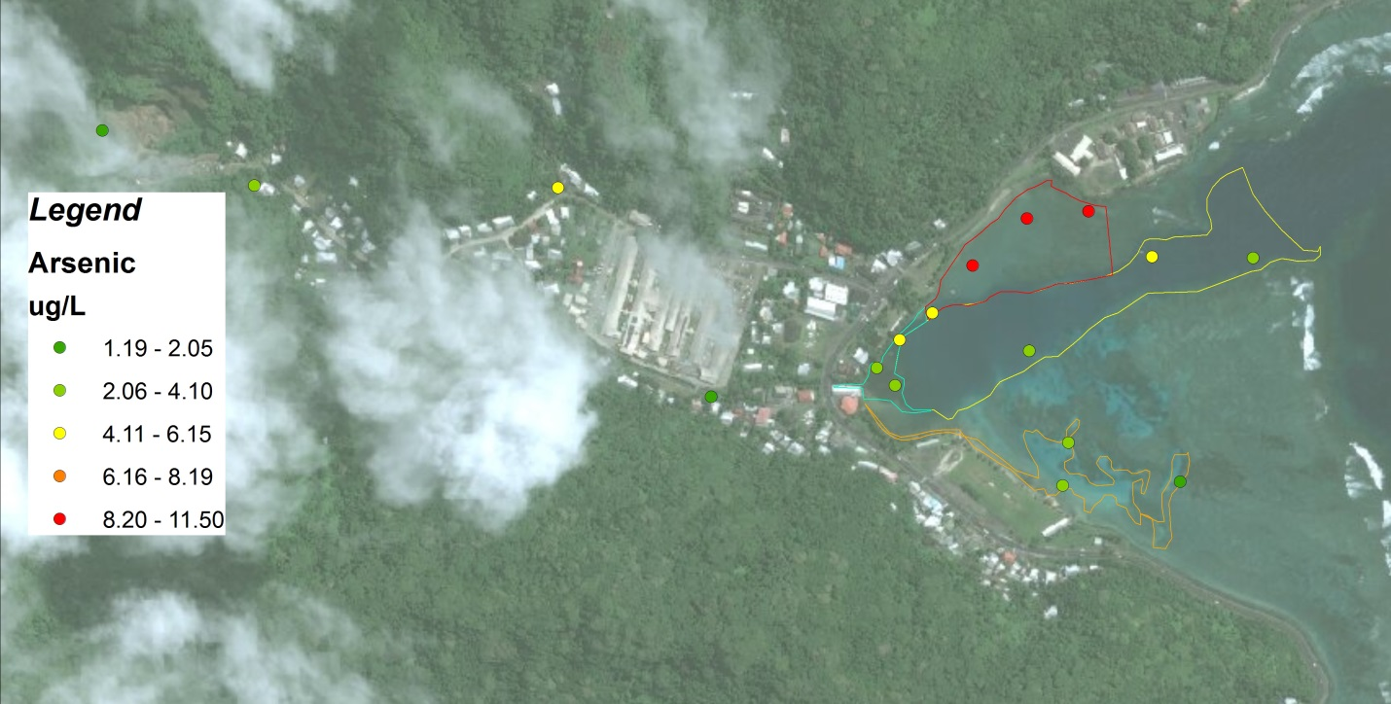

Figure 2: Arsenic concentrations in sediments (January, 2014). Note: highest concentration are in the North Bay area.

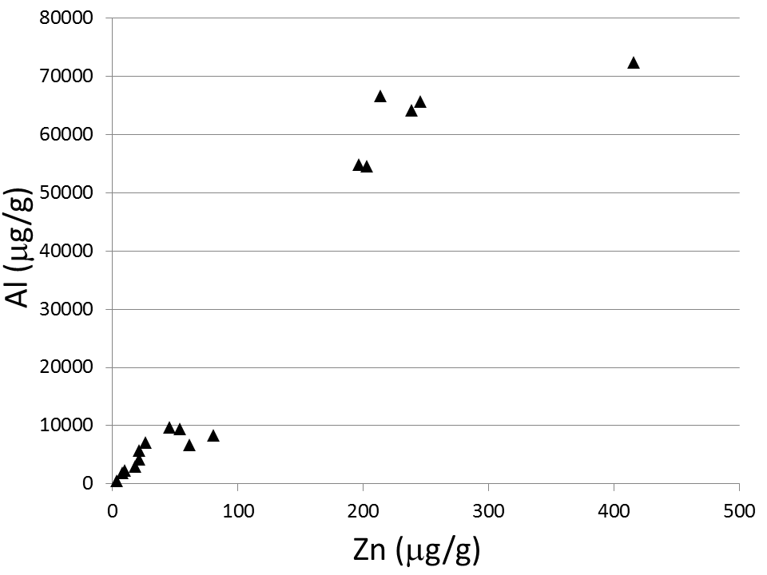

Figure 3: Scatter plot of sediment Zn versus sediment Al. The high degree of correlation between these two crustal elements (Spearman rho=0.96 ) suggests that even though Zn exists at high levels, this is most likely naturally occurring Zn.

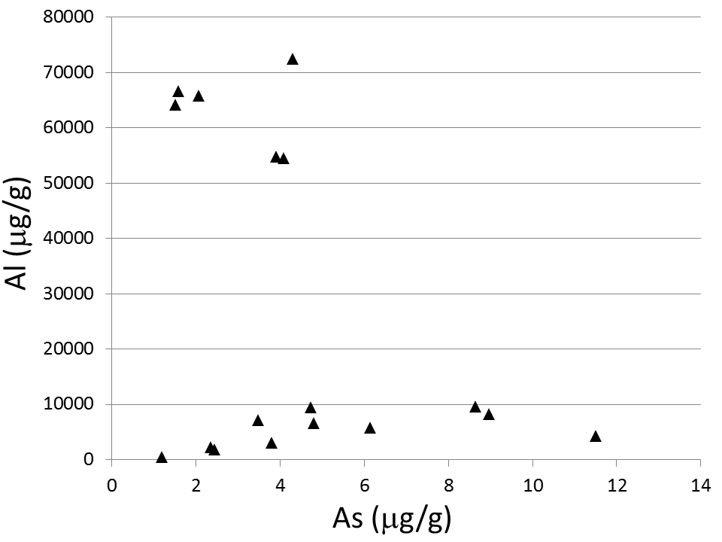

Figure 4: Scatter plot of sediment As versus sediment Al. The lack of correlation between these two crustal elements suggests that high arsenic levels are likely due to anthropogenic sources.

**Recommendations**

We can add this in later as we get further and specific recommendations for each of the above sections are more fully developed.

Contacts of partners and contributors?